Wellspace email templates | Email 1
Health survey / intro email - HR to staff

Subject: Welcome to Wellspace

Welcome to Wellspace, your new health and wellbeing partner provided by CLIENT for all Employees. (https://yourwellspace.com/)

The Wellspace model works through a cleverly designed smartphone application that can provide online access to mental health, physical health, nutrition and sleep resources and content. The app is completely anonymous and your data will remain secure and anonymous at all times.

Before we launch, we would appreciate it if you can complete a very quick anonymous health survey. You can access the survey LINK

These questions are used to understand any positive changes that may occur through the use of the app and associated Wellspace content and service. They are based on scientific research around health and wellbeing designed by Wellspace Head of Wellbeing and Behavior Change Dr Nicola Eccles.

This survey is voluntary and is 100% anonymous, as such no personal identifiable information will be shared with CLIENT.

The results will enable Wellspace to build a platform bespoke to CLIENT over the next 12 months, one that supports our employees, and offers great tips, guidance and advice based on the challenges we face as we navigate through our daily lives.

The app will allow you to track your own personal lifestyle behaviours that you wish to monitor. If you like, you’ll be able to set up personal activity challenges and join group challenges with other members of the company who have also signed up. The app provides data driven content relevant to you based on your interactions within the app on a daily basis.

If you have any questions about the data handling and anonymous nature of the service please see the End User Licence Agreement attached.

Wellspace email templates | Email 2
Launch email - HR to staff

Subject: Download the Wellspace application

We launched Wellspace on a mission to improve mental and physical health and wellbeing by using cutting edge intelligent technologies, real time reporting, online resources, signposting and support for employees around the world.

Today you are invited to download the Wellspace application.

Please open your phone camera and hold it in front of the correct QR code below to take you to the app store to download the Wellspace app. Alternatively, search for “Wellspace” in the app store search option.

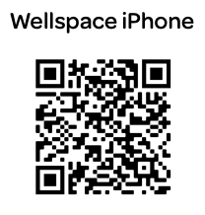
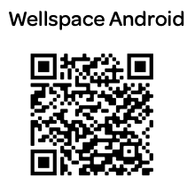
Enter your email address to progress on the registration page.

Your unique account code is XXXX

Please select your team, region and department if prompted.

You can access our FAQs section here for technical help in getting set up.

You can access some walk through videos of the app HERE

If you have any questions about set up or functionality then please don't hesitate to reach out to me directly.

